Digital Cafeteria

Designed and Developed by

[automations.digital](https://automations.digital/)

User Guide

Contact:

Aditya Ajay : 7761839403, [aditya.ajay@outlook.in](mailto:aditya.ajay@outlook.in)

Ayush Pratap Singh: 9990030362, [ayushsinghpratap10@gmail.com](mailto:ayushsinghpratap10@gmail.com)

Table of Contents

1. Hardware Guide

2. Software Guide (Management)

3. Software Guide (Customer)

1. Hardware Guide

1. **Raspberry Pi**: Raspberry Pi is a single board computer which is used in this project to power our kiosk. As with traditional computers, a mouse, a keyboard and a monitor will be attached. To boot up the raspberry pi, simply turn on the power supply. To shut down, go to the power menu and click on shut down.A button (optional) will be provided to shut down the system.
2. **RFID Reader:** An MFRC522 module is used to read data from the ID cards of the users.

2. Software Guide (Management)

The administrator section is intended to be very simple for the layman. The admin section can be accessed at [localhost:8000/admin](http://127.0.0.1:8000/admin) . The login screen is shown in Fig 2.1

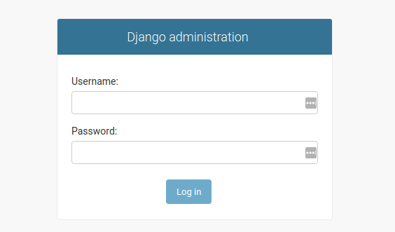

Fig 2.1: Login Screen

The administrator can create accounts for staff with limited access, like changing availability of items, etc.

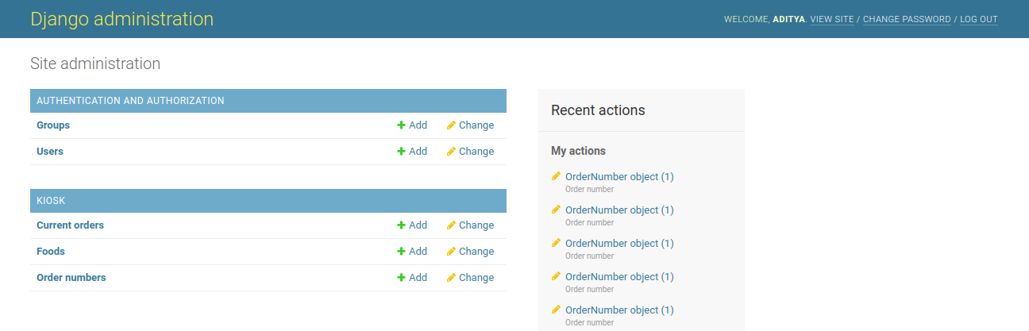 Fig 2.2: Admin Console

The food items can be added in the Foods table as shown here in Fig 2.3

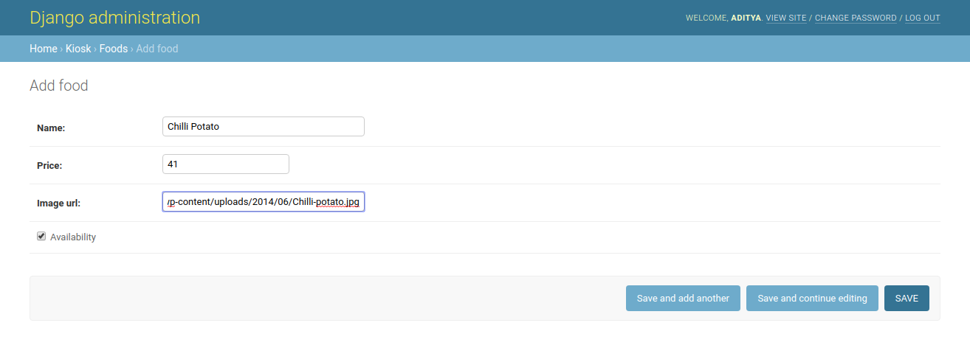 Fig 2.3: Adding/Modifying Food Items

3. Software Guide (Customer)

1. Kiosk View: The system will, by default, boot up to the Kiosk view as shown here in Fig 3.1

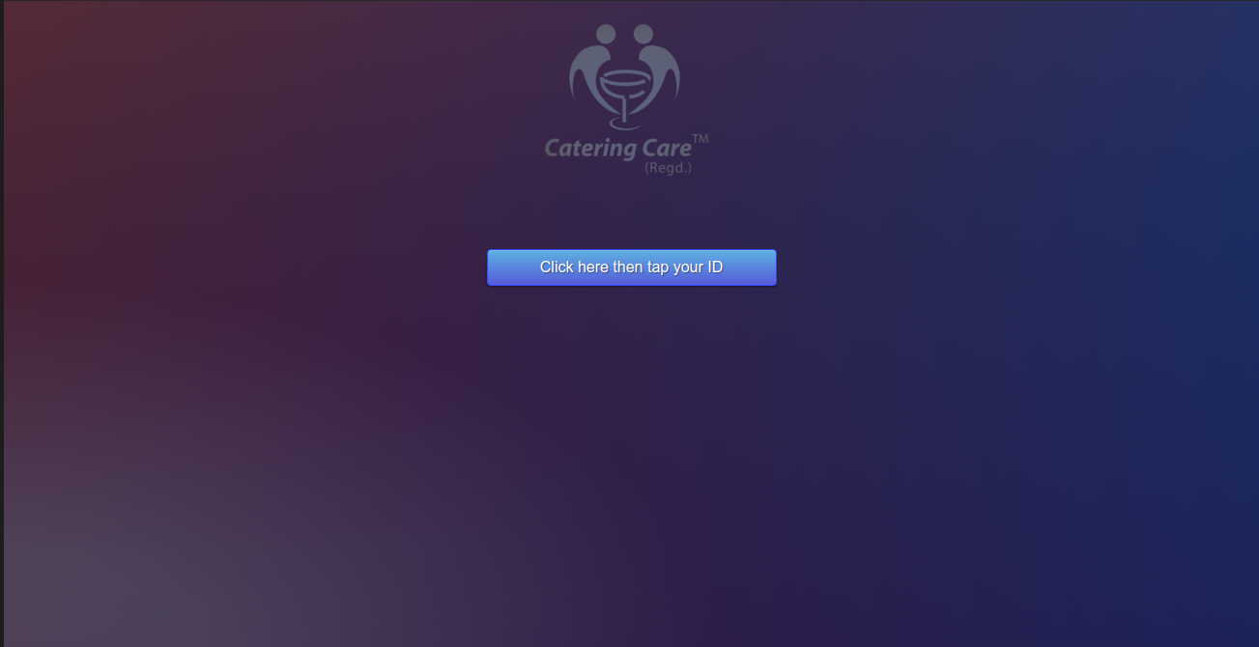  
Fig 3.1: Landing Page

1. On clicking the button, the user will tap his ID which will lead him to the screen shown in Fig 3.2. This order page will display the balance associated with the user’s ID and the items that are available for sale. The user won’t be able to add the items which are marked as unavailable.

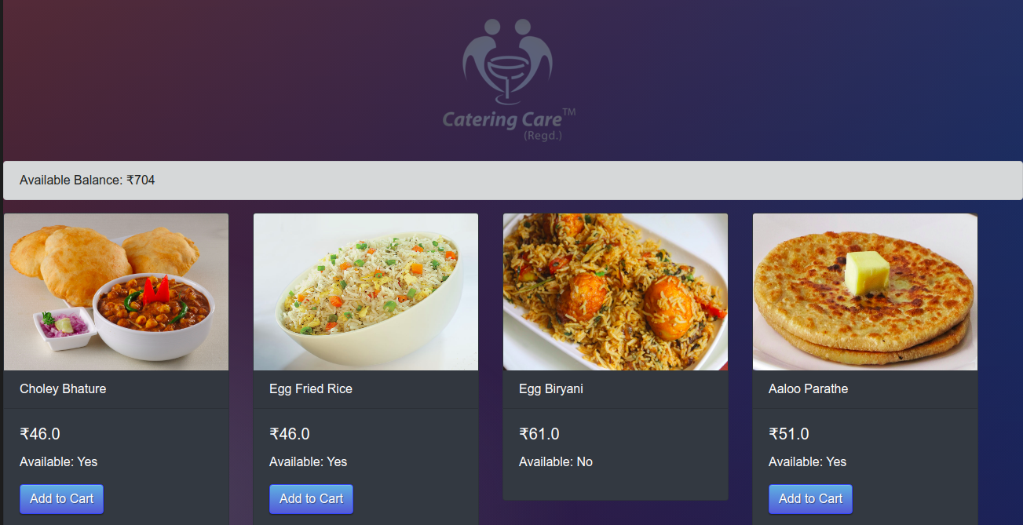  
Fig 3.2 Order Page displaying available balance and items

1. Once items have been selected, the cart icon will appear on the top left screen. When clicked, the user will be redirected to review their cart and confirm payment as shown in Fig 3.3

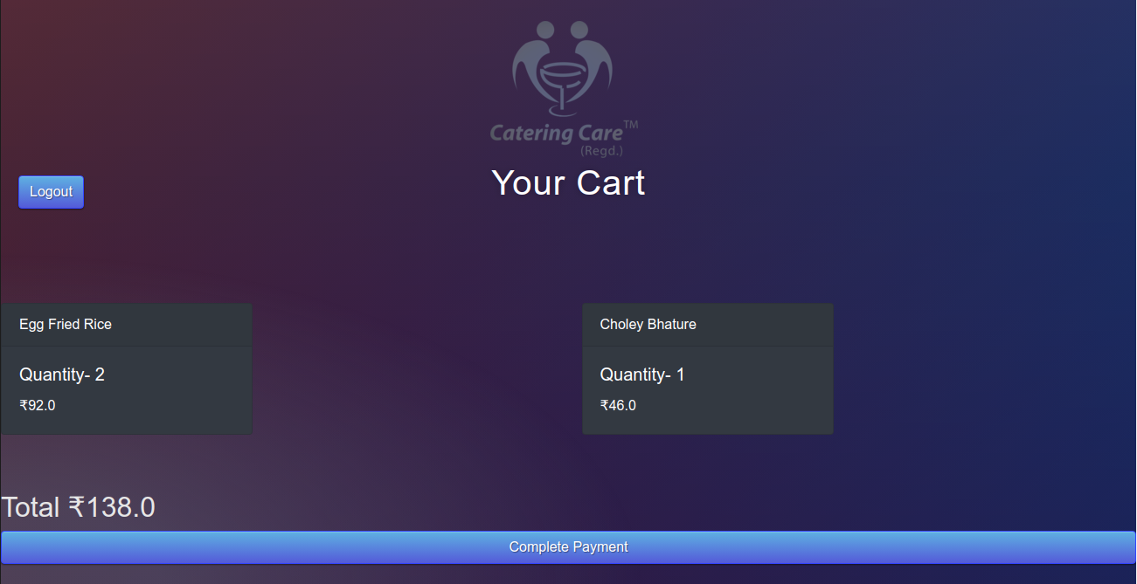  
 Fig 3.3 Cart page

1. 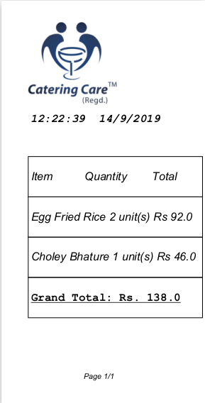Once the user confirms the payment, the bill will be generated and the user’s balance will be updated in the database. The user will then be redirected to the landing page. The bill is shown in Fig 3.4

Fig 3.4 Generated bill